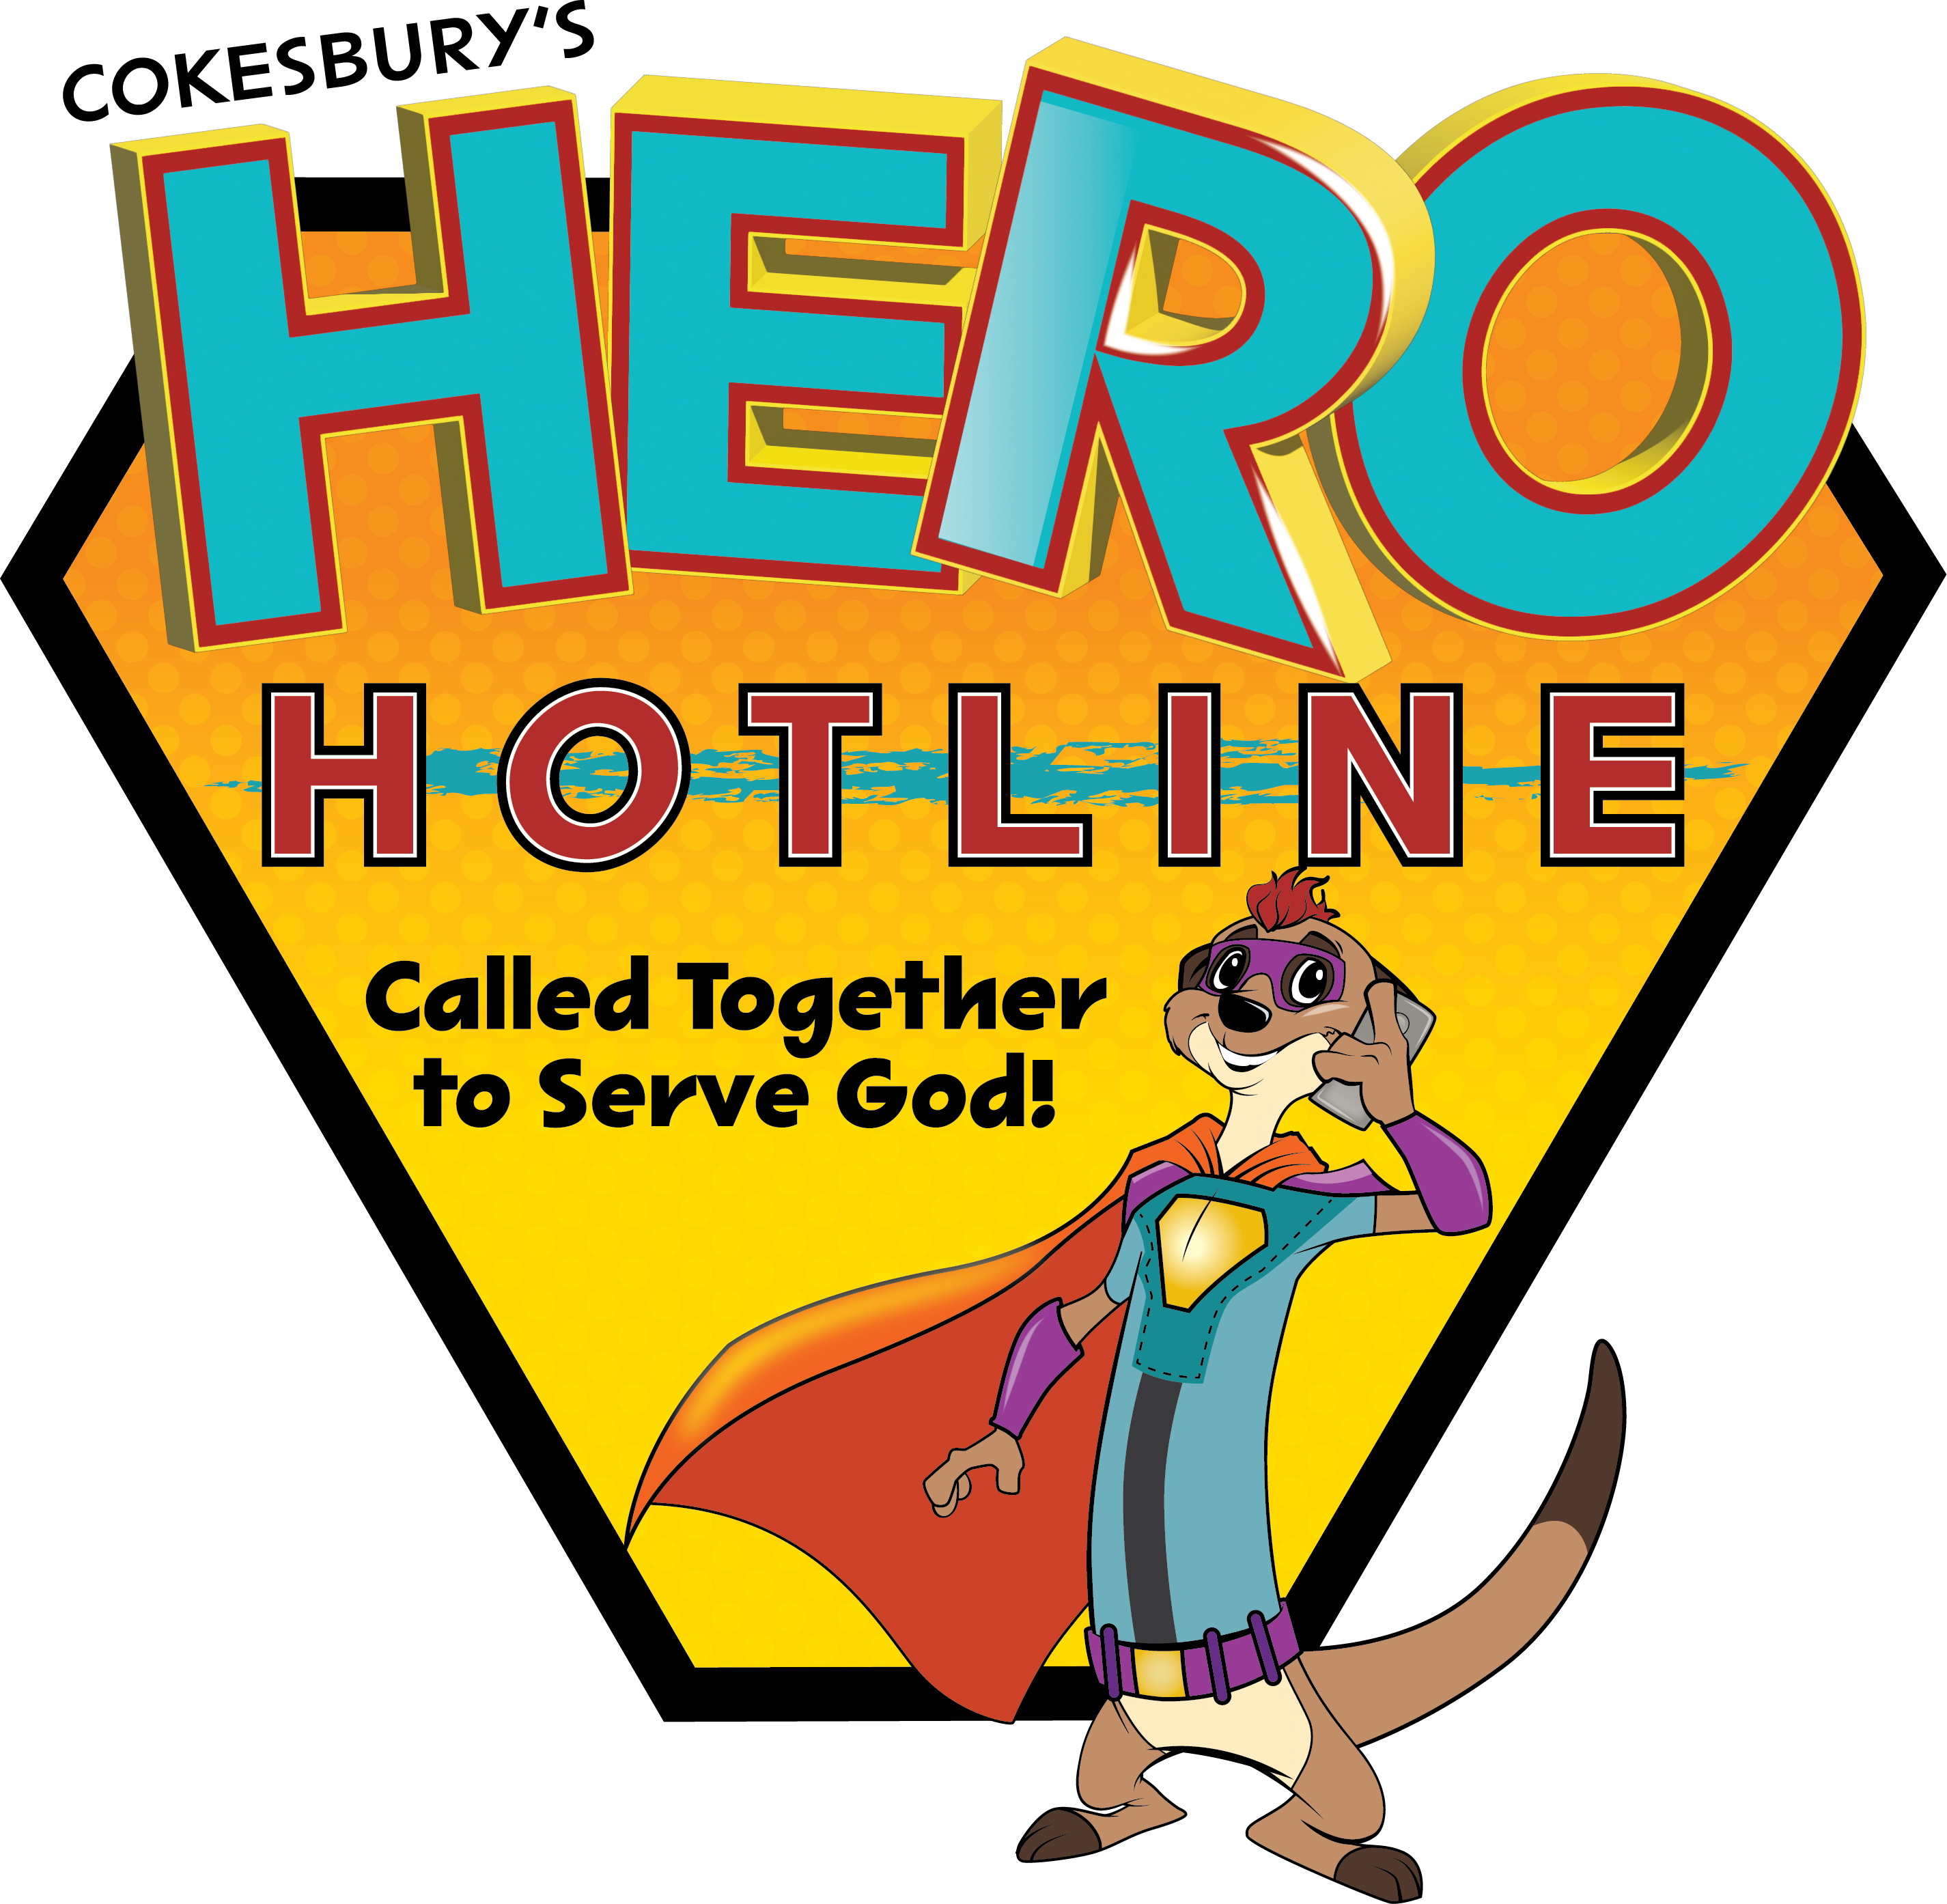
VACATION BIBLE SCHOOL
FIRST PRESBYTERIAN CHURCH

June 19-23

Program begins at 9:00 a.m. and ends at noon.

CHILDREN (3 yrs*– rising 6th grade): Please complete this form
for children to participate in Food Truck Party Vacation Bible
School with Bible study, crafts, snacks, recreation, & music.

* 3 year olds: Is your 3 year old independently potty-trained? □ NO □ YES
Has your 3 year old completed a preschool program? □ NO □ YES If yes, □ full-time or □ part-time

Name_______________________________________ Birthday (mm/dd/yyyy) _______ Grade in fall _______

Name_______________________________________ Birthday (mm/dd/yyyy) _______ Grade in fall _______

Name_______________________________________ Birthday (mm/dd/yyyy) _______ Grade in fall _______

Known allergies: __________________________________________________________________________

________________________________________________________________________________________

ADULTS: VBS is an opportunity for all of God’s children to learn together. Parents (or authorized guardians), if you are able to volunteer, please let us know!

Where would you like to serve? __________________________________________________________________

If you will not be on campus, which adult FPC member volunteer does your child know? ______________________

PARENT/GUARDIAN INFO REQUIRED:

Name: __________________________________________________________________________________

Address: _________________________________________ City:___________________ Zip:____________

E-mail: ___________________________________________ Cell #: ________________________________

DISMISSAL INFORMATION - Who may pick up your child(ren) from VBS?

________________________________________________________________________________________

Are you a 1st time visitor to First Presbyterian Church? _________ yes _________ no

Our Children’s Covenant

Promises we make about how we will treat each other and what we will do to create a safe and sacred space:
- We respect everyone with our words and actions.
- We are kind and work together to be fair to everyone.
- We encourage one another to grow in spiritual ways.
- We support each person’s search for what is right and true in life.
- We listen to our inner voice and to the hopes and concerns of others.
- We work together to make our world peaceful, free, and fair.
- We care for the Earth, its creatures, and our surroundings.

Behavioral Expectations
Families are asked to agree to this covenant before registering for the VBS program. We all make mistakes at times or fail to live up to the promises we have made to one another. At those times, we will lovingly remind each other of our better selves. It is important to remember that behind any misbehavior, there is a need that is not being met. Adult volunteers will start from a place of inquiry with a child before turning to discipline. When children break the covenant:
- The adult VBS volunteer quietly asks the child what is going on to try to understand the unmet need. The adult may make modifications to attempt to meet the child’s need (i.e. provide a sense ball for tangible stimulation, or crayons to color so they can listen better).

- If this does not help, the adult volunteer immediately offers a quiet reminder that the behavior is inappropriate and out of bounds.
- If the behavior continues, the adult and child hold a private conversation.
- If needed, the child has a private conversation with the VBS Director, who will be in touch with the parents.
- After a family conversation, the parents contact the VBS Director to indicate the child understands the behavior was unacceptable and agrees to work harder to keep the covenant.
- In the case of repeated difficulties, a parent/guardian will be asked to accompany and supervise the child for an agreed upon time.
- As a last resort, the child may be asked to take a break from the VBS program.

Assumption of Risk Agreement and Release

I grant permission for the above listed child(ren) to participate in events sponsored by First Presbyterian Church. I fully and forever release and discharge First Presbyterian Church – York, SC from any and all claims, demands, damages, or causes of action, present or future, whether the same be known, anticipated or unanticipated, resulting from or arising out of my and/or my child’s participation in said events or transportation on the First Presbyterian Church bus or other vehicle being used for a First Presbyterian Church event. In the event that I cannot be reached in an emergency, I give permission for the leaders to obtain the necessary medical help.

I have read and understand and sign the Children’s Covenant and Assumption of Risk and Release.

Print Name _____________________________ Signature _____________________________ Date _________

Permission for Use of Images in FPC Media (optional)

I grant permission to First Presbyterian Church to use photographs, written statements, video, and other depictions of the above listed child on websites, in emails, social media, and in print media related to First Presbyterian Church, provided that such depictions are presented in an appropriate and respectful manner.

Print Name _____________________________ Signature _____________________________ Date _________

